**Memo**

To: Professor Pisano

From: Nick Gutierrez, Seok Young Choi, Yumin Lisa Wei, Eunhye Kwon

Team: 24

Date: 2/28/23

Subject: Prototype 2 Demo Testing Plan

1. **Required Materials**

Hardware:

* Adafruit HUZZAH32 Esp32 Feather board
* 1 LiPoly battery
* 8 Capacitive Touch Buttons
* Adafruit MPR121 12-Key Capacitive Touch Sensor Breakout
* 3D printed Controller Casing

Software:

* ESP32 code
  + Reads inputs from touch buttons and maps them to controller inputs which are then sent over Bluetooth to the computer.
* Gamepad HTML tester website
  + <https://gamepad-tester.com/>
* 1 copy of Portal Reloaded to demo in game functionality.

**2.0 Setup**

1. Power the device by flipping the power switch.
2. Press a couple of buttons to verify inputs are being registered.
3. Open the Gamepad Tester site and verify the controller is being picked up.

**3.0 Testing Procedure**

1. Demonstrate how the user’s hands should be placed and joystick mobility.
2. Open the Gamepad testing site and demo each button/joystick corresponding to the correct gamepad output.
3. Open Portal Reloaded and show the controller inputs begin the corresponding action in the game
4. Complete the Lasers level of Portal Reloaded

**4.0 Measurable Criteria**

* Minimal mobility issues when using the palm joysticks and pressing the touch buttons.
* Gamepad testing site shows correct output for controller inputs.
  + Both buttons and joysticks
* Level of Portal Reloaded is demonstrated and completed.

**5.0 Esp Input to Controller Button Mapping**

| **Arduino Button** | **Controller Button** |
| --- | --- |
| Physical Button 1 (BUTTON_0) | Start |
| Physical Button 2 (BUTTON_1) | Select |
| BUTTON_2 | Logo |
| BUTTON_3 | A |
| BUTTON_4 | X |
| BUTTON_5 | LT |
| BUTTON_6 | LB |
| BUTTON_7 | RB |
| BUTTON_8 | RT |
| BUTTON_9 | A |
| BUTTON_10 | B |

**Figure 1**: Schematic of controller. This controller has an Adafruit HUZZAH32 Esp32 Feather, 8 touch buttons, and two joysticks.

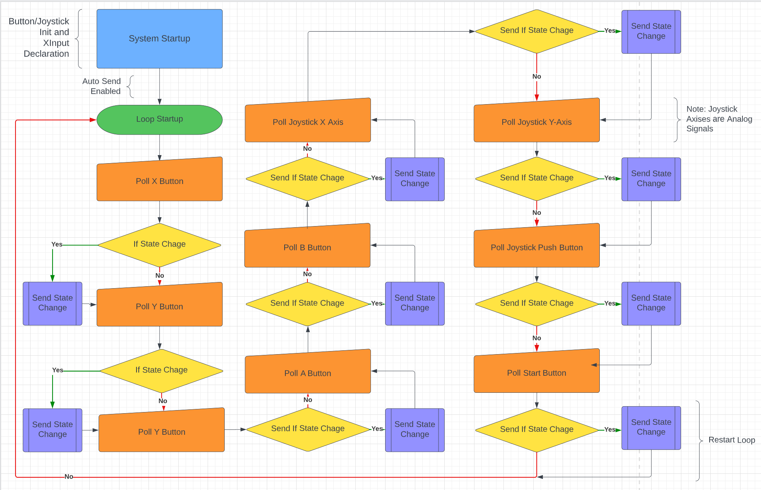

**Figure 2:** Software Flow Diagram of Controller

**6.0 Score Sheet**

**6.1 Controller Hardware/Software Testing**

**Table 1**: Controller buttons and joysticks testing results. The functionality of buttons and joysticks will be tested through LED outputs, gaming controller outputs, and game action performances.

| Button | Correct Controller Output? | Game Action Performed? | Button Hard to Press? | Total Score |
| --- | --- | --- | --- | --- |
| BUTTON_0 |  |  |  |  |
| BUTTON_1 |  |  |  |  |
| BUTTON_2 |  |  |  |  |
| BUTTON_3 |  |  |  |  |
| BUTTON_4 |  |  |  |  |
| BUTTON_5 |  |  |  |  |
| BUTTON_6 |  |  |  |  |
| BUTTON_7 |  |  |  |  |
| BUTTON_8 |  |  |  |  |
| BUTTON_9 |  |  |  |  |
| BUTTON_10 |  |  |  |  |